E-Health Care
PHASE-I PROJECT REPORT

SUBMITTED BY

HARIHARAN.V- [ RA2411026010560]
VARSHINI.M.S - [RA2411026010544]
ASHIKA KUMARI – [RA2411026010542]
PRATHYUSH HARAN.S – [RA2411026010545]

UNDER THE GUIDANCE OF
Dr. Antony Sophia N

21CSC203P – ADVANCED PROGRAMMING PRACTICE

DEPARTMENT OF COMPUTING TECHNOLOGIES


FACULTY OF ENGINEERING AND TECHNOLOGY
SCHOOL OF COMPUTING
SRM INSTITUTE OF SCIENCE AND TECHNOLOGY

KATTANKULATHUR
OCTOBER 2025

Abstract
The E-Health Care system is a comprehensive desktop-based application designed to streamline medical shop management. Its primary aim is to simplify administrative tasks by providing an intuitive graphical user interface (GUI) built using Java Swing. The system connects to MySQL and SQLite databases to enable real-time storage, retrieval, and update of medical data. Through modules for drug inventory tracking, expiry alerts, the application ensures accuracy, efficiency, and compliance with healthcare standards. The results demonstrate improved workflow efficiency, reduced manual errors, and enhanced accessibility of patient and drug records, making E-Health Care a reliable and scalable solution for modern healthcare administration.
Keywords:
E-Health Care, Medical Shop Management, Java Swing,

Problem Statement:
E-Health Care addresses challenges in medical shop management, offering a user-centric solution with a seamless interface for pharmaceutical product management. The platform's intuitive design reduces administrative burdens, empowering administrators to focus on customer service and maintaining a compliant inventory. E-Health Care revolutionizes medical shop operations, emphasizing precision and compliance and overall business success in the evolving healthcare landscape.
Objectives

- Simplify medical shop management through an easy-to-use interface.
- Improve workflow efficiency with automated data handling.
- Ensure accuracy and compliance using real-time alerts and validation.
- Streamline patient appointment scheduling and updates.
- Design a scalable system adaptable for future healthcare needs.

- Introduction:

The front-end of the E-Health Care application plays a vital role in bridging the gap between users and the system’s backend functionality. It has been designed with a focus on simplicity, clarity, and efficiency, ensuring that even non-technical users such as pharmacists or medical shop administrators can operate it with ease.
This application has been developed in a front-end frameworks:
- Java Swing (for desktop-based medical shop management)
Interface prioritizes a graphical user interface (GUI) that facilitates seamless interaction with the database, enabling real-time monitoring, management, and updates of healthcare data.
The interface adheres to the principles of user-centered design, where every button, label, and field is positioned to maximize efficiency and minimize cognitive load. This ensures that administrators can focus on productivity without being overwhelmed by complex workflows.

- ARCHITECTURE AND DESIGN(JAVA):

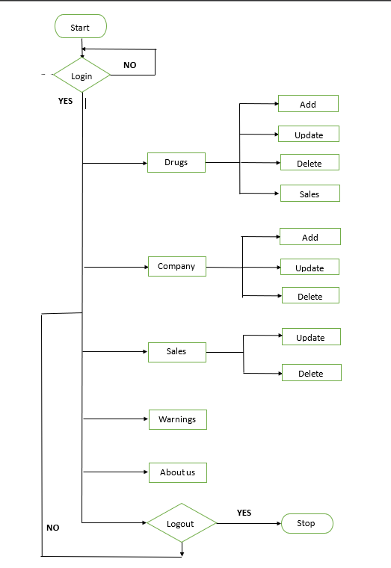

- Java Front-End (Swing GUI):

3.1 Framework Used
The Java Swing framework was chosen for its flexibility and ability to create modern desktop GUIs. Swing provides components such as JFrame, JLabel, JButton, and JTable to construct the layout efficiently.
3.2 Layout Structure
The main window acts as the central hub of operations. It contains:
- A header label displaying the project title: “E-Health Care – Drug Management System.”
- Input fields for entering product details (Drug ID, Name, Batch, Quantity, Expiry Date).
- Buttons for major actions — Add, Update, Delete, and View Records.
- A summary label showing Total Drugs Available in real-time, updated from the database.

3.3 Functional Flow
- Initialization:
When the application starts, the Application class initializes the Swing window and establishes a JDBC connection with the MySQL database.
- Adding a Record:
When a user enters drug details and clicks Add, the input data is validated, inserted into the database, and a success message is displayed using JOptionPane.
- Updating Records:
The Update button allows the user to modify existing records. It fetches current values from the database and opens a pop-up form for editing.
- Deleting Records:
The Delete function removes outdated or expired entries after confirmation.
- Viewing Data:
A JTable displays all stored drug details, offering a tabular summary with sorting and scrolling options.
- Real-Time Alerts:
A warning system integrated into the front-end automatically displays notifications when a drug is nearing expiry or stock levels fall below threshold.

3.4 Visual Design
The design uses a neutral colour palette (white/grey background with blue highlights) and large, readable fonts. Each component is spaced evenly for better readability. Layout managers such as Grid Layout and Border Layout ensure consistent alignment.
3.5 Key Strengths
- Intuitive layout with easy navigation.
- Direct real-time database connectivity for instant updates.
- Visual alerts enhance safety and compliance.
- Professional desktop appearance suitable for enterprise environments.

4.Results and output:

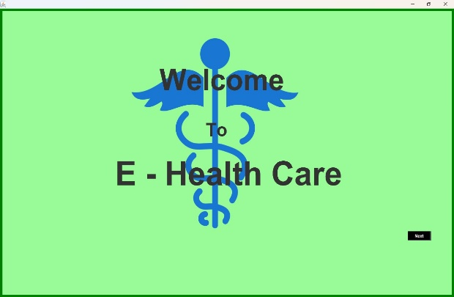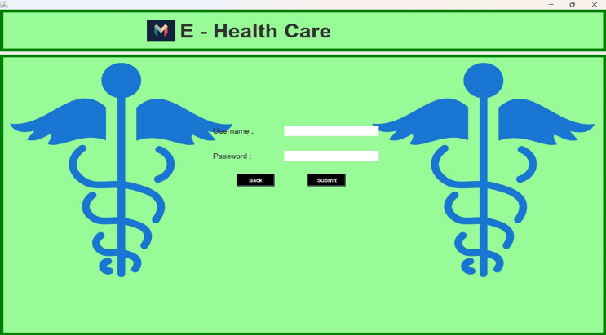
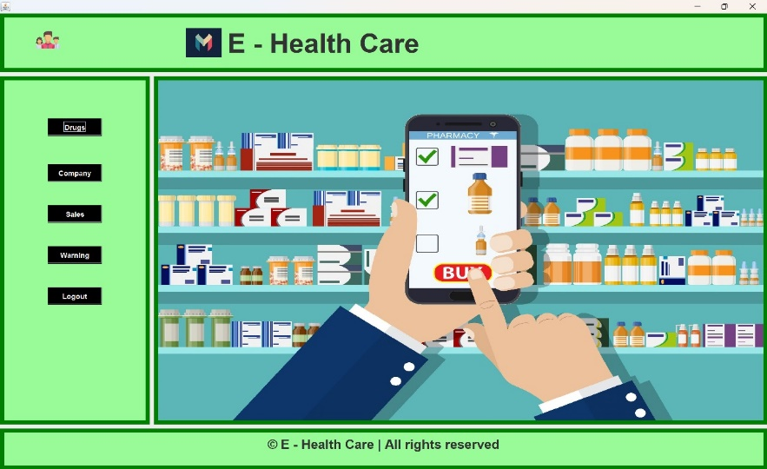

5. Conclusion:
The front-end of E-Health Care demonstrates an excellent blend of design aesthetics and functional efficiency. Java implementations exhibits clarity, modularity, and smooth operation.
The GUI ensures administrators can manage drugs, appointments, and records without technical difficulty. The Swing-based interface focuses on inventory control and proactive alerts.
Overall, the E-Health Care front-end is an effective and scalable model of how healthcare software can integrate usability with functionality. Its strong GUI foundation ensures it can be expanded further into a comprehensive healthcare management platform supporting automation, analytics, and remote access in the future.

